Remin Shaju
32 MCA B Batch

exam@debian:~$ mkdir sales
exam@debian:~$ cd sales
exam@debian:~/sales$ mkdir location1 location2 location3
exam@debian:~/sales$ ls
location1 location2 location3
exam@debian:~/sales$ cd location1
exam@debian:~/sales/location1$ touch sales1.txt sales2.txt sales3.txt
exam@debian:~/sales/location1$ ls
sales1.txt sales2.txt sales3.txt
exam@debian:~/sales/location1$ cd ..
exam@debian:~/sales$ cd location2
exam@debian:~/sales/location2$ touch pur1.txt pur2.txt
exam@debian:~/sales/location2$ ls
pur1.txt pur2.txt
exam@debian:~/sales/location2$ cd ..
exam@debian:~/sales$ cd location3
exam@debian:~/sales/location3$ touch stock1.txt stock2.txt
exam@debian:~/sales/location3$ ls
stock1.txt stock2.txt
exam@debian:~/sales/location3$ cd ..
exam@debian:~/sales$ cd location2
exam@debian:~/sales/location2$ cat > pur1.txt
hai
exam@debian:~/sales/location2$ cat pur1.txt pur2.txt >> pur3.txt
exam@debian:~/sales/location2$ ls
pur1.txt pur2.txt pur3.txt
exam@debian:~/sales/location2$ cd ..
exam@debian:~/sales$ cd location2
exam@debian:~/sales/location2$ cp pur3.txt ~/sales/location3/stock3.txt
exam@debian:~/sales/location2$ ls
pur1.txt pur2.txt pur3.txt
exam@debian:~/sales/location2$ cd ..
exam@debian:~/sales$ cd location3
exam@debian:~/sales/location3$ ls
stock1.txt stock2.txt stock3.txt
exam@debian:~/sales/location3$ ls -l
total 4
-rw-r--r-- 1 exam exam 0 Oct 8 14:29 stock1.txt
-rw-r--r-- 1 exam exam 0 Oct 8 14:29 stock2.txt
-rw-r--r-- 1 exam exam 4 Oct 8 14:33 stock3.txt
exam@debian:~/sales/location3$ chmod g+wrx stock3.txt
exam@debian:~/sales/location3$ ls -l
total 8
-rw-r--r-- 1 exam exam 33 Oct 8 14:35 stock1.txt
-rw-r--r-- 1 exam exam 0 Oct 8 14:29 stock2.txt
-rw-rwxr-- 1 exam exam 4 Oct 8 14:33 stock3.txt
exam@debian:~/sales/location3$

exam@debian:~/sales/location3$ cat > stock1.txt
1
2
3
4
5
6
7
8
9
10
11
12
13
14
exam@debian:~/sales/location3$ head -10 stock1.txt
1
2
3
4
5
6
7
8
9
10
exam@debian:~/sales/location3$ cd ..
exam@debian:~/sales$ ls
location1 location2 location3
exam@debian:~/sales$ ls -al
total 20
drwxr-xr-x 5 exam exam 4096 Oct 8 14:27 .
drwxr-xr-x 20 exam exam 4096 Oct 8 15:59 ..
drwxr-xr-x 2 exam exam 4096 Oct 8 14:28 location1
drwxr-xr-x 2 exam exam 4096 Oct 8 14:32 location2
drwxr-xr-x 2 exam exam 4096 Oct 8 14:33 location3
exam@debian:~/sales$ cd ..

2Q)write shell script to find volume of sphere,cube,cylinder use case

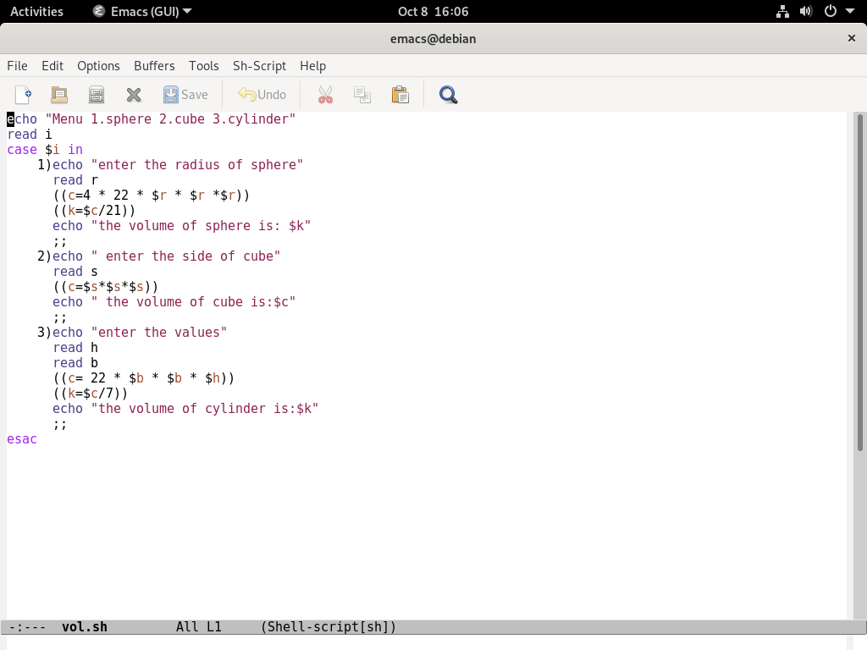

outtput
